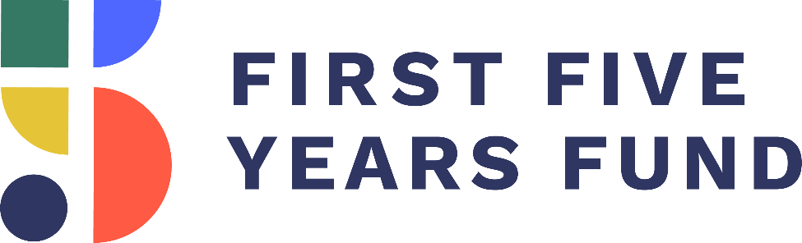

2018 High-Quality
Early Learning
and Care Toolkit

www.ffyf.org

Overview

This document has been prepared by the First Five Years Fund (FFYF) to serve as a resource regarding access to affordable early childhood education opportunities. The document also provides facts and messaging about policies and programs that, directly or indirectly, help achieve the goal of improving access to affordable early learning and child care from birth through age five.

This resource is intended for policymakers and their staffs, as well as early childhood education stakeholders and advocates, and serves as an up-to-date guide for ways to discuss federal support for, and investments in, early learning and child care. With your leadership, we have achieved significant progress over the past year in advancing priorities that benefit our nation's youngest learners. This document will help your team articulate all of the gains you have helped secure, as well as identify opportunities for you to demonstrate how this support benefits your community.

This resource is by no means limited to these identified audiences. We hope anyone seeking to learn more about the importance of investing in early learning and child care initiatives finds this document useful.

If you have follow-up questions on the material in this document or are interested in additional information on a specific topic or policy, feel free to email Amanda Guarino, FFYF Policy Director, at aguarino@ffyf.org. Please also contact us for assistance in scheduling a site visit or tour in your state or district. For more information on local programs and providers, see page 19.

Table of Contents

- Key Early Childhood Education Facts and Talking Points P. 4

- Why Make High-Quality Early Childhood Education A Priority? P. 8

- Evidence for National Bipartisan Support P. 10

- Recent Budget and Appropriations Developments P. 14

- Top 10 Early Childhood Education In-District Activities P. 17

- Opportunities for Congressional Involvement P. 19

- Opportunities for Local Involvement P. 21

- FFYF Poll Fact Sheet P. 23

I. Key Early Childhood Education Facts and Talking Points

Effective Ideas and Phrases

Whether you choose to adapt and use the talking points below or craft your own message, here are some key phrases and ideas to keep in mind for effective messaging. These phrases and ideas have been used consistently by supporters of early childhood education, and tested to determine their effectiveness when discussing the importance and popularity of investment in early childhood education initiatives.

Ideas that resonate with a bipartisan audience:

- Parents are a child’s first and best teachers, and high-quality early childhood programs help them support their children’s healthy development and education while they work or attend school.
- Expanding access and options for parents to provide their children a quality early childhood education has proven benefits for individuals and society in reduced healthcare costs, increased school achievement, and a more educated workforce.
- The overwhelming evidence shows that children who enter kindergarten behind are likely to remain behind throughout their educational careers and beyond.
- We can help ensure children show up to kindergarten ready to learn by providing our youngest learners with options to access high-quality early childhood education.
- Access to affordable, reliable, and high-quality child care opportunities provides working families with better job stability and overall economic security, while ensuring children are developing the skills that prepare them for school and a lifetime of success.

Key narratives to highlight:

- During the first five years, a child’s brain is at its most flexible, making this a critical period for learning and growth. What children learn and experience in these first years of life can change the course of their lives.
- Quality child care is not a luxury, it is a necessity. Yet child care is often one of the largest expenses families face each month.
- Participants in high-quality early childhood education also show long-term gains in the form of lower rates of incarceration, lower rates of arrest for violent crimes, and are less likely to have received government assistance later in life.
- A vast majority of American voters want Congress and the administration to work together to improve the quality of child care and preschool, and make it more affordable for parents.
- Most Americans say they would be willing to pay higher taxes to address children's issues, even if their own children wouldn't directly benefit.

Sample Talking Points

Investing in early childhood education now is an investment in our community's future. That's why I'm proud of our recent efforts in Congress to provide federal support for early learning and child care programs throughout our state.
- Children from low-income families who receive a high-quality early childhood education are more likely to earn higher wages, live healthier lives, avoid incarceration, raise stronger families, and contribute to society.
  - High-quality early childhood education is also associated with long-term health benefits, including reduced rates of depression, smoking, and substance abuse.
  - Other long-term gains include lower rates of incarceration (46 percent reduction) and lower rates of arrest for violent crimes (33 percent reduction), and lower likelihood of receiving government assistance (26 percent reduction).
- The benefits of high-quality programs from birth through age five do not end with one child but extend to their entire family, now and in the years to come.
  - The positive effects of early childhood interventions are evident even 30 years in the future.
  - Access to stable, high-quality child care also helps parents improve labor productivity by allowing parents to increase hours worked, miss fewer work days, and pursue education.

This year, Members of Congress on both sides of the aisle have come together multiple times to take bipartisan action in support of our nation's youngest constituents.
- The FY2019 Labor/HHS Minibus package again prioritized the care of America’s young children by including a $260 million increase for federal early learning and care programs.
  - The bill increased funding for the Child Care and Development Block Grant (CCDBG) program by $50 million to a total of $5.28 billion in discretionary funding, building on the historic $2.37 billion increase the program received in FY2018 through a bipartisan deal.
  - The bill also increased funding levels for Head Start and Early Head Start by $200 million for a total of $10.06 billion and the IDEA Preschool Grants program by $10 million for a total of $391.12 million, while continuing funding for the Preschool Development Grants program at $250 million.
- The FY2018 Omnibus Appropriations bill included a significant funding increase for some of the nation's vital early learning and care programs.
  - The bill increased discretionary funding for the Child Care and Development Block Grant (CCDBG) program to $5.23 billion – the single largest increase to CCDBG in the program's history. This represents an increase of $2.37 billion over FY2017 levels and nearly doubled the program's discretionary funding.
  - The bill also included significant funding levels for Early Head Start and Head Start, as well as the Preschool Development Grants program, setting funding for those programs at $9.86 billion and $250 million, respectively.
- In February, the Maternal, Infant, and Early Childhood Home Visiting Program (MIECHV) was reauthorized for five years under the Bipartisan Budget Act of 2018.
  - This critical program provides funds to states and local grantees for developing and implementing voluntary, evidence-based home visiting programs to support at-risk families.
  - Home visitors meet with families at home and work with parents, from pregnancy through their child's kindergarten entry, to help lay the foundation for the health, education, development, and economic self-sufficiency of the entire family. Visits by caring, experienced professionals can turn good intentions into good parenting, breaking generations-long cycles of poverty.
  - Prior to its reauthorization, the program expired in September of 2017.

These investments will allow more access to high-quality programs to give children a strong foundation for the future, regardless of socioeconomic background.
- When children enter kindergarten behind their peers, they are more likely to stay behind. Particularly for children from low-income families, these achievement gaps persist through high-school, impacting the rest of their lives.
  - High-quality early childhood education reduces attendees' timidity and improves attentiveness.
  - High-quality early learning programs aimed at disadvantaged children help close the achievement gap, increasing IQ scores by up to 10 points.
- Investing in high-quality care in a child's first five years ensures they develop the skills necessary for learning, decreasing the need to invest in costly inventions later in life.
  - Preschool reduced the percentage of children repeating a grade by 15 percent. It also lowered the rate of special education placement by 10 percent.
  - Early learning and care increases high school graduation rates by 14 percent.

Early childhood education programs help support working parents across the country. With a record number of women in the workforce today, working moms in particular stand to benefit from these investments in child care and early learning programs.
- Without access to early learning and care, parents tend to miss work, lowering household incomes and potentially leading to job loss.
  - A lack of child care causes businesses to lose an estimated $4.4 billion annually due to employee absenteeism.
  - Working families who can't access affordable child care lose $8.3 billion in wages annually.
- Access to affordable, reliable, and high-quality early learning and care opportunities provides working families with better job stability and overall economic security.
  - Child care helps parents return to work and generate an additional $79,000 in lifetime earnings for mothers.
- Unfortunately, the need to access this critical support far outpaces current capacity, and many families across the country cannot afford the cost of quality child care.
  - Today, center-based care costs families an average of $10,000 dollars per year.
  - A lack of child care causes 45 percent of parents to miss work.

Supporting families with the cost of quality preschool and child care will result in a more efficient and productive workforce for years to come, strengthening our communities and setting a strong foundation for the future.

II. Why Make High-Quality Early Childhood Education a Priority?

- Overwhelming research shows the earliest years of a child's life – birth through age five – are critical for their physical, social, language, and cognitive development, all of which are essential to future success.
  - During these first five years, a child's brain is most flexible, making this period of learning and growth critical for future development.
  - More than one million new neural connections are formed every second in the first few years of life, and 90 percent of the physical volume of a child's brain develops as early as five years old.
- Science tells us that children who face adversity in the first years of life, such as poverty and prolonged exposure to trauma like hunger, parental incarceration or family drug abuse, are more at risk for experiencing damages to their brain architecture, which can lead to lifelong problems in learning, behavior, and physical and mental health.
  - High-quality early learning and care is proven to help mitigate the effects of toxic stress on a child's brain by providing safe, supportive, nurturing relationships that support healthy development.
  - Parents and other primary caregivers help teach children how to regulate their emotions and establish a sense of safety, which are essential aspects of physical and emotional development.
- Studies show support for early childhood education is one of the greatest uses of public funding in terms of return on investment.
  - According to a recent study led by Harvard Education Professor Dana McCoy, early childhood education reduces special education placement, reduces time spent in the same grade, and increases high school graduation rates.
  - Nobel Prize-winning economist James Heckman's research supports these results. Heckman's work showed targeted early childhood education programs aimed at disadvantaged children produced a 13.7 annual return on investment, amounting to $7.30 in societal gains for each dollar invested.
- Unfortunately, too many children, particularly those from low-income backgrounds, do not have access to the high-quality early childhood education proven to offset the effects poverty can have on their development.
  - Less than half of low-income children have access to high-quality early childhood programs that could dramatically improve their opportunities for a better future.
- States have made significant progress in implementing policies that support high-quality early childhood education.
  - For example, states have increased pre-k funding by 47 percent in the last five years, and research shows these are smart investments.
- Waiting until kindergarten is too late.
  - Expanding access to high-quality early childhood education and making it more affordable is an investment that leads to short- and long-term gains, not only for the individuals impacted, but for their families, their communities, and society at large.

III. Evidence for National Bipartisan Support

Congress has a strong, bipartisan track record of support for funding early learning programs. Members on both sides of the aisle have worked together in the spirit of bipartisanship to significantly increase funding, while also enacting reforms to existing early childhood programs that elevate quality and leverage state and local leadership.
Because Congress has been a powerful advocate, more children from birth through age five are able to access critical resources to prepare them for school and life. Congress' continued efforts will help ensure our youngest learners have access to a continuum of high-quality early learning from the very start.
This year, Republican and Democratic Governors from every corner of the nation have used their annual State of the State addresses to highlight their commitment to early childhood education. In fact, one in three U.S. governors who delivered State of the State addresses in 2018 specifically highlighted early learning initiatives. Of those, 59 percent were Republican Governors, and 41 percent were Democrats.
The legislation enacted, as described below, are just a few of the most recent examples of Congress' commitment on behalf of children across the country.

FY2019 Labor/HHS Minibus Package
- Enacted: 9/28/18 (House Vote: 361-61; Senate Vote 93-7)
- Description: The FY2019 Labor/HHS Minibus package again prioritized the care of America’s young children by including a $260 million increase for federal early learning and care programs. The bill increased funding for the Child Care and Development Block Grant (CCDBG) program by $50 million to a total of $5.28 billion in discretionary funding, building on the historic $2.37 billion increase the program received in FY2018 through a bipartisan deal.
  - The bill also increased funding levels for Head Start and Early Head Start by $200 million for a total of $10.06 billion and the IDEA Part B Preschool Grants program by $10 million for a total of $391.12 million, while continuing funding for the Preschool Development Grants program at $250 million.
  - The FY2019 Labor/HHS Minibus package also includes:
    - $805 million for Early Head Start-Child Care Partnerships;
    - $50 million for Child Care Means Parents in School;
    - $5 million for Infant and Early Childhood Mental Health;
    - $391.12 million for IDEA Part B Preschool Grants; and
    - $470 million for IDEA Part C Grants for Infants and Families.
- What This Means: The funding levels included in the FY2019 Labor/HHS Minibus package will support greater access to, and the quality of early childhood education programs that are proven to support children’s healthy development and prepare them for a life of achievement. The funding increases for early learning in the FY2019 Labor/HHS Minibus package were only possible as a result of support by both Republican and Democratic members of Congress.
FY2018 Omnibus Bill
- Enacted: 3/23/18 (House Vote: 256-167; Senate Vote 65-32)
- Description: The FY2018 Omnibus bill included a historic funding increase for some of the nation's vital early learning and care programs. The bill increased discretionary funding for the Child Care and Development Block Grant (CCDBG) program to $5.23 billion – the single largest increase to CCDBG in the program's history. This represents an increase of $2.37 billion over FY2017 levels and nearly doubled the program's discretionary funding.
  - The bill also included significant funding levels for Early Head Start and Head Start, as well as the Preschool Development Grants (PDG) program, setting funding for those programs at $9.86 billion and $250 million respectively. This funding for Head Start and Early Head Start represented an increase of $610 million over FY2017, and includes an expansion of Early Head Start and the Early Head Start-Child Care Partnerships.
  - The FY2018 Omnibus bill also includes:
    - $755 million for Early Head Start-Child Care Partnerships;
    - $50 million for Child Care Means Parents in School;
    - $5 million for Infant and Early Childhood Mental Health;
    - $381.12 million for IDEA Part B Preschool Grants; and
    - $470 million for IDEA Part C Grants for Infants and Families.
- What This Means: Overwhelming bipartisan support on Capitol Hill for early childhood education made greater funding levels possible. CCDBG was last authorized in 2014 to strengthen health and safety requirements for child care providers, increase quality, and improve transparency so families are equipped to choose care that best meets their child’s and family’s needs. The funding increases in the 2018 Omnibus bill will go a long way towards ensuring states are more equipped with the resources needed to continue implementing these important but often costly program improvements, which will in turn promote learning and healthy development.

Maternal Infant and Early Childhood Home Visiting (MIECHV)
- Reauthorized: 2/9/18 (House Vote: 240-186; Senate Vote: 71-28) under the Bipartisan Budget Act of 2018
- Description: Home visits, conducted by nurses, social workers, and trained professionals, support pregnant women and families with young children by providing access to critical resources in the early years. The extension of MIECHV under the Bipartisan Budget Act of 2018 maintained current funding levels of $400M per year.
- What This Means: The partnership between families and home visitors improves health and development, prevents child injuries, reduces ER visits, reduces domestic violence, improves family economic self-sufficiency, and improves the coordination and referrals for other community resources. Many families who participate in voluntary home visiting live in rural parts of the country, a long distance from critical services, making the support they receive from home visiting all the more critical to child and family outcomes.

Child And Dependent Care Tax Credit
- Reauthorized: 12/22/17 (House Vote: 224-201; Senate Vote: 51-48) under the Tax Cuts And Jobs Act
- Description: The Child and Dependent Care Tax Credit (CDCTC) is the only credit in the tax code specifically created to help families with the the cost of work-related child care expenses. After months of uncertainty surrounding the fate of the CDCTC within the tax reform discussion, bipartisan leaders in the Senate prevailed in early December in protecting the credit from being eliminated in the legislation. Last-minute efforts to include an amendment that would have made the credit refundable were unsuccessful, however, leaving the credit unchanged and still out of reach for many low- and middle-income families with lower tax liability.
- What This Means: The CDCTC was created in 1976 to help working parents with work-related child care expenses. Congress approved a temporary increase to the credit in 2001, and in 2012 a bipartisan majority voted to make that expansion permanent. Because the CDCTC is not a refundable credit, most low- and some middle-income, tax-paying families with qualified expenses are unable to take advantage of the credit. Therefore, higher-income families have benefited most from the tax credit. FFYF is working with bipartisan leaders to strengthen the CDCTC so that more families – particularly those who would benefit most – are eligible to receive it.
The Every Student Succeeds Act (ESSA)
- Enacted: 12/10/15 (House Vote: 359-64; Senate Vote: 85-12)
- Description: This education law replaced its outdated predecessor, the No Child Left Behind Act (NCLB). ESSA accomplishes the following:
  - Shifts decision-making responsibility to states with federal guardrails for quality;
  - Incorporates early learning provisions throughout; and
  - Authorizes dedicated funding for early learning through the Preschool Development Grants program.
- What This Means: States have the opportunity to use federal dollars to invest in early learning, enabling them to build upon local innovations to coordinate an early childhood system and allowing states to take the lead on increasing access to preschool. The departure from NCLB's federal emphasis means that states will take on more decision-making responsibilities and will be able to address early learning needs as they exist within a state's specific context.

Child Care and Development Block Grant (CCDBG)
- Reauthorized: 11/19/14 (House Vote: Voice Vote; Senate Vote: 88-1)
- Appropriations: A discretionary funding increase of $2.37 billion was included in the FY2018 Omnibus bill, nearly doubling the program's funding. Additionally, the FY2019 Labor/HHS Minibus package provided a discretionary funding increase of $50 million.
- Description: First enacted in 1990, CCDBG is the primary federal funding source providing financial assistance to low-income working families that access child care. In November 2014, the CCDBG Act was reauthorized with bipartisan support for the first time in 18 years. In order to improve the quality of child care programs, the reauthorized law includes reforms aimed at promoting family involvement, strengthening health and safety standards, improving training for the child care workforce, enhancing continuity of care, and increasing the percentage of children from low-income families in high-quality programs. The increase of $2.37 billion in FY2018 and the $50 million increase in FY2019 for CCDBG will help states implement the quality improvements put forth in the Act, leading to better outcomes for children from low-income families.
- What This Means: States are struggling with the cost of implementing the critically important reforms included in CCDBG reauthorization. Increased funding in the FY2018 Omnibus bill and the FY2019 Labor/HHS Minibus package will enable states to provide children and families access to high-quality child care without being forced to reduce the already shrinking numbers of children who receive child care assistance or reduce payments to child care providers. The reforms Congress passed into law hold great promise, but without continued funding increases, the goals of CCDBG reauthorization could go unfulfilled and working parents will find it even more challenging to obtain the help in paying for child care that they need to find and keep a job to support their children.

IV. Recent Budget and Appropriations Developments

Federal funding is crucial to promoting investment in early learning at the state and local level. This support ensures early learning programs can properly serve families and accomplish the goals and activities authorized by law. Fortunately, even in the face of limited resources, Congress has consistently increased funding levels for early learning and care programs with overwhelming bipartisan support. The following programs make up the core federal support for early childhood education and child care that receive funding through Congressional appropriations.

Child Care and Development Block Grants (CCDBG)
- Congress agreed to a much-needed increase for the Child Care and Development Block Grant (CCDBG) program in its 2018 bipartisan budget deal. As a result of the two-year budget deal, the FY2018 Omnibus bill increased funding by $2.37 billion for CCDBG, nearly doubling the program’s discretionary funding. The FY2019 Labor/HHS Minibus package built on this historic increase and provided an additional $50 million increase for CCDBG in FY2019 for a total of $5.28 billion.
- CCDBG, in partnership and coordination with other early learning funding at the federal, state, and local levels, allows parents to work while their children attend child care that promotes learning and healthy development. Establishing continuous access to affordable, reliable, and high-quality early learning and care opportunities promotes job stability for working families and overall economic security.
- HHS' FY2019 budget documents state that CCDBG and Head Start "offer a two-generation strategy toward upward economic mobility that allows parents and guardians to pursue self-sufficiency while helping their children receive care and education." By significantly increasing investment in CCDBG, American families and the American economy stand to benefit both from a child development and a workforce standpoint.
Preschool Development Grants (PDGs)
- The FY2018 Omnibus bill and the FY2019 Labor/HHS Minibus package provided funding for the Preschool Development Grant (PDG) program at $250 million, which is the same as the FY2017 level.
- The purpose of PDGs is to improve the coordination and quality of, as well as access to, early childhood education programs for low- and moderate-income children from birth to age five.
- PDGs encourage thoughtful strategic planning and promote sharing of best practices among early childhood education program providers. This collaboration ensures federal, state, and local resources are used effectively to support a continuum of care for young learners.
- The PDG program was authorized with bipartisan support under the Every Student Succeeds Act (ESSA) as a way to improve the delivery of high-quality early learning for our most vulnerable children by bolstering coordination and collaboration.

Head Start
- The FY2019 Labor/HHS Minibus package and the FY2018 Omnibus bill included significant funding increases for Early Head Start and Head Start of $200 million and $610 million, respectively. In FY2019, the total funding level for Early Head Start and Head Start is $10.06 billion, including an expansion of Early Head Start and the Early Head Start-Child Care Partnerships.
- Head Start centers on empowering families and communities with the knowledge and resources they need to ensure that the next generation is able to succeed at every stage of life. It is an especially critical resource for families who would otherwise lack access to high-quality child care and early learning services. According to a 2018 report from the Center for American Progress, Head Start serves nearly every rural county in America, delivering educational, health, and parent education services.
- Research shows that continuous access to full-day, full-year early childhood education improves the likelihood of successful outcomes for young children from low-income backgrounds. Based on this research, HHS revised its Head Start Program Performance Standards in November 2016 to focus on positive child outcomes, including the expectation that, over time, all Head Start programs would serve children for a full school day and full school year.
  - However, HHS recently had to waive a requirement that 50 percent of Head Start center-based programs extend their services to the equivalent of full-day, full-year by August 2019. The notice of the waiver stated that this action was necessary due to insufficient funding.
  - 100 percent of Head Start center-based programs will need to provide the equivalent of full-day, full-year by August 1, 2021.
Early Head Start-Child Care Partnerships
- Congress demonstrated its continued commitment to the importance of the Early Head Start Expansion and Early Head Start – Child Care Partnerships (EHS-CCP) by including a $50 million increase in the FY2019 Labor/HHS Minibus package, which built on a $115 million increase in the FY2018 Omnibus bill.
- EHS-CCP bring together the best of Early Head Start and child care through layered funding to provide comprehensive and continuous services to low-income infants, toddlers, and their families. Under EHS-CCPs, 275 grantee partners with more than 1,400 local child care centers and 1,000 family child care programs are providing quality early childhood education for over 32,000 infants and toddlers.

EARLY LEARNING FUNDING ADVOCACY EFFORTS
PROGRAM |  | FY2018 FUNDING  LEVEL | FY2019 HOUSE APPROPS SUBCOMMITTEE | FY2019 SENATE APPROPS SUBCOMMITTEE | FY2019  FUNDING LEVEL
HEAD START/  EARLY HEAD START | TOTAL PROGRAM  FUNDING | $9.86 billion | $9.91 billion | $10.11 billion | $10.06 billion
 | Funding Increase | +$610 million | +$50 million  (over FY2018) | +250 million  (over FY2018) | +$200 million  (over 2018)
 | Early Head Start –  Child Care Partnerships  (EHS-CCP) | $755 million | $780 million | $755 million | $805 million
 | EHS-CCP Increase | +$115 million | +$25 million  (over FY2018) | Level | +$50 million  (over FY2018)
PRESCHOOL  DEVELOPMENT GRANTS | TOTAL PROGRAM FUNDING | $250 million | $250 million | $250 million | $250 million
 | Funding Increase | Level | Level | Level | Level
CHILD CARE AND DEVELOPMENT  BLOCK GRANT | TOTAL DISCRETIONARY PROGRAM  FUNDING | $5.23 billion | $5.23 billion | $5.23 billion | $5.28 billion
 | Funding Increase | +$2.37 billion | Level with FY2018 – maintains funding increase | Level with FY2018 - maintains funding increase | +$50 million  (over FY2018)

V. Top 10 Early Childhood Education In-District Activities

In-district work periods are times for members to go home and reconnect with the communities they serve. At home this summer, here are ten things you can do to promote early childhood care and education.

- Host a neighborhood roundtable on quality child care in your area.
Early childhood care and education is a priority for voters. According to FFYF's national poll, 89 percent of voters support making quality early childhood education for children more affordable for working families. Seventy-nine percent of voters want Congress and the Administration to work together to improve the quality of child care and preschool, and to make these opportunities more affordable.

- Meet with nurses or other home visiting practitioners funded by the Maternal, Infant, and Early Childhood Home Visiting (MIECHV) Program, and accompany them on a visit.
Parents are a child's first and best teacher. But for parents who are experiencing poverty, drug addiction, language barriers or geographic isolation, voluntary home visiting can be a valuable resource for supporting them to be the best advocate for their child's learning, health, and development in the early years, including serving pregnant mothers. Through regular, planned, and voluntary home visits, parents develop skills aimed at supporting their family's health and economic self-sufficiency. Meeting with a trained home visiting provider and joining a home visit is a great way to learn more about this vital lifeline to families across America.

- Host a community meeting with early learning providers and professionals to discuss their experiences in the classroom.
Teachers are on the front lines when it comes to early learning and child care. Thus, conversations with teachers are critical to finding out about the issues affecting children in your community. These conversations are also a great way to empower teachers to make positive changes and advocate for the policies that they believe in.

- Tour a child care facility.
Pick a local child care facility and schedule a visit to learn more and connect with local children and child care professionals. Not sure where the closest child care facility is located? Reference our list of contacts for each state on page 19 of this resource.

- Visit with families participating in home-based child care.
Most children in America are cared for by home-based child care providers. Every day, thousands of Americans open their homes and hearts to children from their communities. These small businesses are on the front lines of making sure children start out strong. Visit with these professionals and the families they serve to see the importance of diversity in options for parents, and the needs of these providers.

- Read to a group of children in your community.
Reading and speaking to children is one of the best ways to build their vocabulary and help their brains grow and develop. Taking an afternoon to read to local children is a great way to promote the value of reading and education in your community, and encourage literacy for children and adults.

- Write an op-ed on federal support for early childhood care and education.
As a Member of Congress, your support for early childhood education can mean the world to families struggling to find options for their children. Writing an op-ed on your support for the programs that many of these families rely on is a great way to connect with your constituents, and use your platform to speak up for the youngest constituents in your community.

- Organize a task force on early childhood education.
Convening community stakeholders is the best way to find out information about the issues that are truly affecting children and families in your area. Local providers and educators are a great start; in addition, try inviting local professors, entrepreneurs, health care professionals, and parents from the area. This type of task force can serve as a driving factor behind local early childhood education initiatives throughout the year.

- Meet with a child psychologist to discuss the effects of the opioid epidemic on children and families in your community.
The opioid epidemic has presented new challenges to early learning and child care providers and psychologists in communities across the U.S., as these individuals are on the front lines when it comes to childhood trauma. Exposure to adverse childhood experiences or potential dependencies at birth, such as those resulting from a parent's addiction to opioids, can have an emotional and developmental effect on children for the rest of their lives. As noted in a House Dear Colleague Letter in April 2018, Head Start programs are already treating neonatal abstinence syndrome and employing other resources to help families overcome addiction. Home visiting has also been proven to have a positive effect on at-risk families who may be struggling with addiction. By supporting programs like Head Start and home visiting, lawmakers can ensure families receive personal support from pregnancy through their children's first years of life.

- Ask business leaders about the importance of access to quality child care for their employees.
Research shows lack of access to affordable child care has a dramatic effect on businesses and economic productivity in the U.S. In addition to causing about half of parents to miss work at least once every six months due to child care breakdowns, lack of access to affordable child care contributes to a nationwide cost of $8.3 billion in lost wages annually. Access to stable, high-quality child care helps parents improve their labor productivity by increasing work hours, missing fewer work days, and pursuing further education. Visiting with local business owners to discuss the need for affordable child care options is a great way to show support for pro-family workplace policies that encourage both economic growth and access to high-quality early childhood education.

VI. Opportunities for Congressional Involvement

Congress has a strong bipartisan track record of working together on behalf of America's youngest learners and their families. Below please find information on relevant Congressional caucuses that are currently working to achieve strong investments and partnerships with states and communities through bipartisan federal advocacy.

Congressional Pre-K Caucus:
The Congressional Pre-K Caucus is a bipartisan group that seeks to gain a deeper understanding of the benefits of early childhood education and promote policy recommendations to expand high-quality pre-k access in the United States.

- Rep. Joaquin Castro – (D-TX-20) (Co-chair)
- Rep. Katherine Clark – (D-MA-05) (Co-chair)
- Rep. Thomas Cole – R-OK-04 (Co-chair)
- Rep. Kevin Yoder – R-KS-03 (Co-chair)

- Rep. Stephen Cohen – (D-TN-09)
- Rep. Deborah Dingell – (D-MI-12)
- Rep. James Langevin – (D-RI-02)
- Rep. Richard Nolan – (D-MN-08)
- Rep. Tom O'Halleran – (D-AZ-01)
- Rep. Scott Peters – (D-CA-52)
- Rep. Robert (Bobby) Scott – (D-VA-03)

For information on joining the Congressional Pre-K Caucus, please reach out to the offices of the co-chairs:

Rep. Joaquin Castro
202-225-3236
1221 Longworth House Office Building
http://castro.house.gov/

Rep. Katherine Clark
202-225-2836
1415 Longworth House Office Building
http://katherineclark.house.gov/

Rep. Thomas Cole
202-225-6165
2467 Rayburn House Office Building
http://cole.house.gov/

Rep. Kevin Yoder
202-225-2865
2433 Rayburn House Office Building
http://yoder.house.gov/

Congressional Baby Caucus
The Congressional Baby Caucus aims to ensure public policy reflects the latest research in understanding how children's brains are shaped and developed, how positive behaviors can be encouraged, and how investments in early childhood create success in later years. The group is also committed to ensuring families are supported with the resources they need to take advantage of scientific advances.
The Caucus focuses on a broad range of areas, including: nutrition and basic needs for babies; the effects of trauma; and federal programs like Head Start and Child Care and Development Block Grants.

- Rep. Rosa DeLauro – (D-CT-03) (Co-chair)
- Rep. Charles Fleischmann – (R-TN-03) (Co-chair)
- Rep. Brendan Boyle – (D-PA-13)
- Rep. Robert Brady – (D-PA-01)
- Rep. Julia Brownley – (D-CA-26)
- Rep. Katherine Clark – (D-MA-05)
- Rep. Jim Cooper – (D-TN-05)
- Rep. Deborah Dingell – (D-MI-12)
- Rep. Raul Grijalva – (D-AZ-03)
- Rep. Jim Himes – (D-CT-04)
- Rep. Dave Joyce – (R-OH-14 )
- Rep. Betty McCollum – (D-MN-04)
- Rep. Jared Polis – (D-CO-02)
- Rep. Mark Takano – (D-CA-41)
- Rep. John Yarmuth – (D-KY-03)

For information on joining the Congressional Baby Caucus, please reach out to the offices of the co-chairs:

Rep. Rosa DeLauro
202-225-3661
2413 Rayburn House Office Building
http://delauro.house.gov/

Rep. Charles Fleischmann
202-225-3271
2410 Rayburn House Office Building
http://fleischmann.house.gov

VII. Opportunities for Local Involvement

High-quality early childhood education is a practical, non-partisan issue. While visiting your district, it is helpful to connect with advocates in your community to learn about the best ways to help children and families access high-quality early childhood education. These conversations can set the groundwork for legislative efforts all year round. Below please find contact information for an early childhood education advocacy group in your state helping to craft policies that provide lasting economic and social returns.

If your state is not listed, please contact Helene Stebbins, Deputy Director at Alliance for Early Success, at hstebbins@earlysuccess.org or (703) 769-2772.

State | First | Last | Organization | Email | Phone
AL | Gail | Piggott | Alabama Partnership for Children | gpiggott@smartstartalabama.org
AR | Rich | Huddleston | AR Advocates for Children and Families | jrhuddleston@aradvocates.org
AR | Cory | Biggs | ForwARd Arkansas | cbiggs@forwardarkansas.org
AZ | Kelley | Murphy | Children's Action Alliance | caa@azchildren.org | 602-266-0707
CA | Karla | Pleitez-Howell | Advancement Project California | kpleitezhowell@advanceproj.org
CA | Stacy | Lee | Children Now | slee@childrennow.org | 213-973-5081
CO | Charlotte | Brantley | Clayton Early Learning | CBrantley@claytonearlylearning.org
CO | Bill | Jaeger | CO Children's Campaign | bill@coloradokids.org
DC | Shana | Bartley | DC Action for Children | sbartley@dckids.org
FL | Brittany | Birken | Florida Children's Council | bbirken@floridacsc.org
GA | Mindy | Binderman | Georgia Early Education Alliance for Ready Students | mbinderman@geears.org | 678-689-3482
IA | Sheila | Hansen | Iowa Child and Family Policy Center | shansen@cfpciowa.org
IL | Ireta | Gasner | Ounce of Prevention Fund | igasner@ounceofprevention.org
KS | Annie | McCay | Kansas Action for Children | annie@kac.org
KY | Brigitte | Blom Ramsey | Prichard Committee for Academic Excellence | brigitte.blomramsey@prichardcommittee.org
LA | Melanie | Bronfin | Louisiana Policy Institute for Children | mmbronfin@policyinstitutela.com | 504-228-0988
MA | Amy | O'Leary | Strategies for Children, Inc. | aoleary@earlyeducationforall.org | 617-330-7384
MD | Clinton | Macsherry | Maryland Family Network | cmacsherry@marylandfamilynetwork.org
ME | Rita | Furlow | Maine Children's Alliance | rfurlow@mekids.org | 207-623-1868
MI | Michelle | Richard | Public Sector Consultants | mrichard@publicsectorconsultants.com | 517-331-9466
MI | John | Bebow | The Center for Michigan | jbebow@thecenterformichigan.net
MN | Nancy | Jost | West Central Initiative | njost@wcif.org
MS | Rachel | Canter | Mississippi First | rachel@mississippifirst.org
NE | Becky | Veak | First Five Nebraska | bveak@firstfivenebraska.org | 402-261-9671
NJ | Cecilia | Zalkind | Advocates for Children of New Jersey | czalkind@acnj.org | 973-643-3876
NM | Katherine | Freeman | New Mexico Early Childhood Development Partnership | katherinef@uwsfc.org | 505-982-2002
NY | Betty | Holcomb | Center for Children's Initiatives | bholcomb@ccinyc.org | 973-865-5315
NC | Tracey | Zimmerman | NC Early Childhood Foundation | tzimmerman@buildthefoundation.org
OK | Debra | Andersen | Oklahoma Partnership for School Readiness | debra.andersen@smartstartok@org | 405-429-4219
OH | Shannon | Jones | Groundwork Ohio | sjones@groundworkohio.org
OH | Brandi | Slaughter | Voices for Ohio Children | brandi@raiseyourvoiceforkids.org
OR | Dana | Hepper | Children's Institute | dana@childinst.org | 503-219-9034
PA | Joan | Benso | Pennsylvania Partnerships for Children | Jbenso@papartnerships.org | 717-236-5680
PA | Nelida | Sepulveda | Public Citizens for Children and Youth | nelidas@pccy.org
RI | Elizabeth | Burke Bryant | RI KIDS COUNT | ebb@rikidscount.org | 401-351-9400
TN | Blair | Taylor | Memphis Tomorrow (Tennesseans for Quality Early Education) | btaylor@memphistomorrow.org | 901-322-8080
TX | Mandi | Kimball | Children at Risk | mkimball@childrenatrisk.org | 713-869-7740
TX | Stephanie | Rubin | Texans Care for Children | srubin@txchildren.org | 512-473-2274
TX | Sophie | Phillips | TexProtects | sophie@texprotects.org
VA | Kathy | Glazer | Virginia Early Childhood Foundation | Kathy@vecf.org
WA | Jon | Gould | WA Children's Alliance | Jon@childrensalliance.org
WI | Dave | Edie | Kids Forward | DEdie@kidsforward.net

VIII. FFYF Poll Fact Sheet
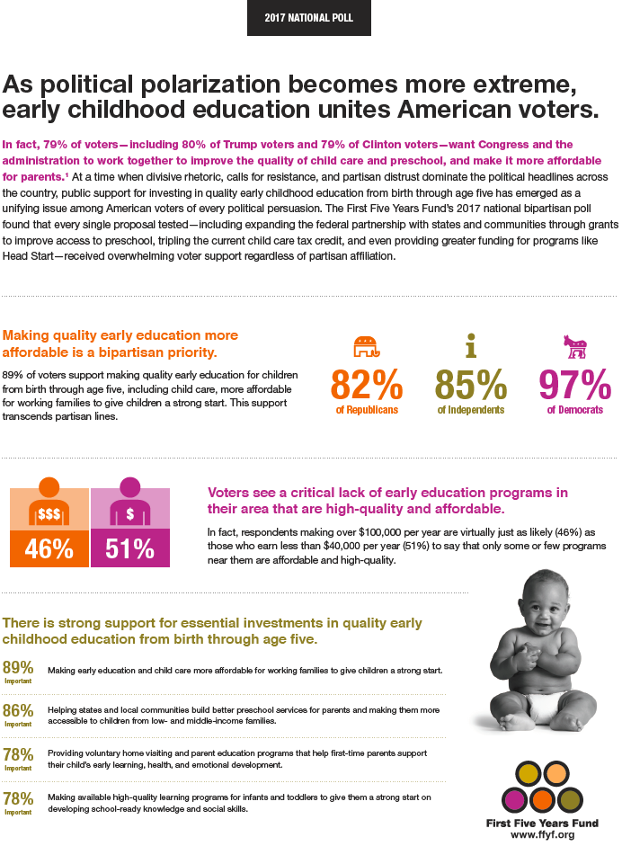
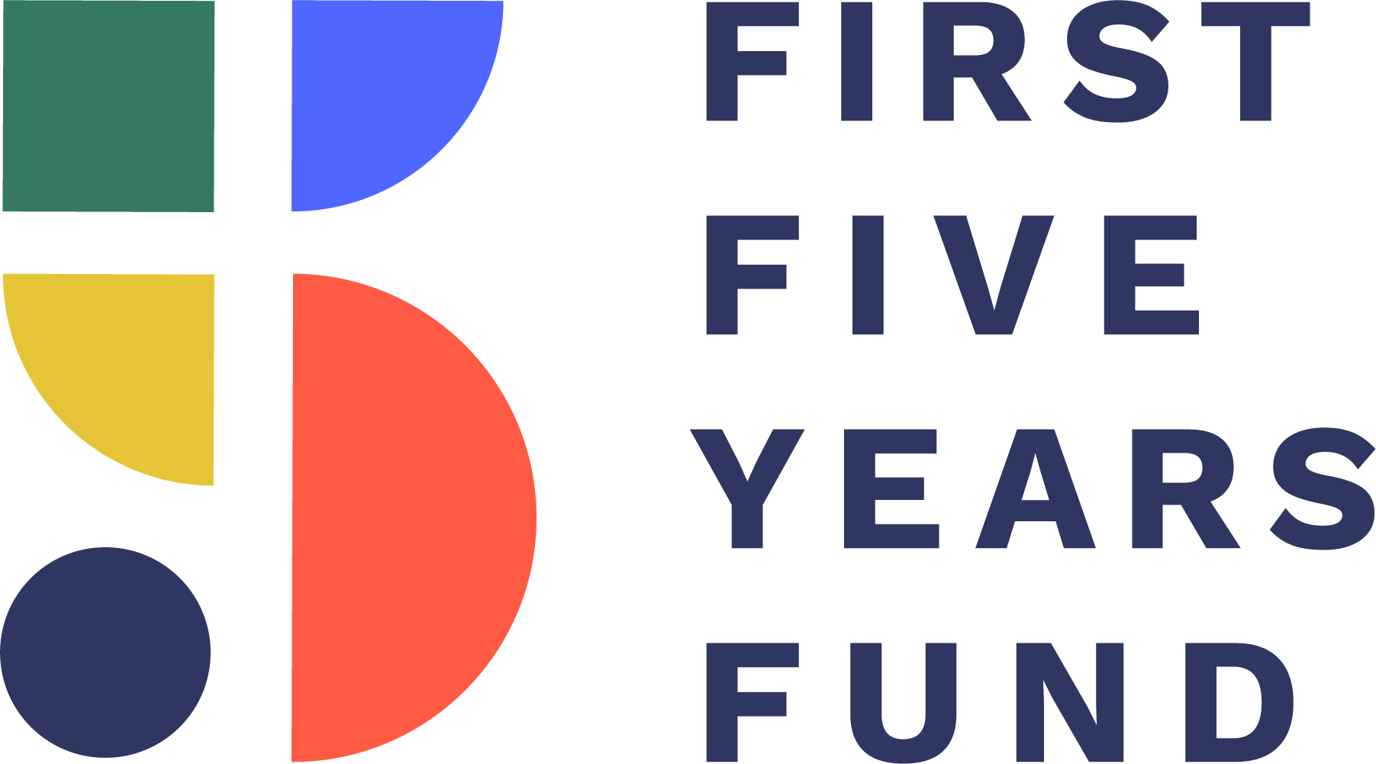
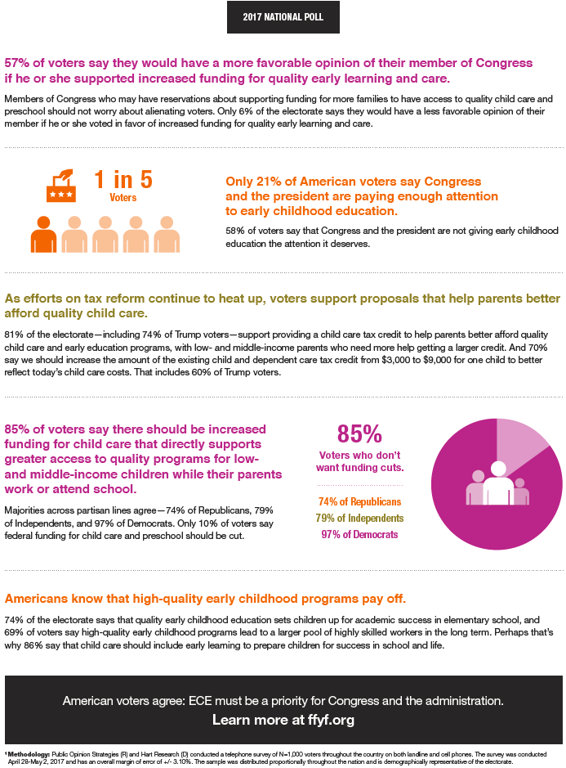

Ibid.
Lynn Karoly, Anamarie Auger, "Informing Investments In Preschool Quality And Access In Cincinnati," Rand Corporation, 2016
Coalition For Evidence-Based Policy, Website, Accessed 1/4/17
Arthur Reynolds Et Al., "Effects Of A School-Based, Early Childhood Intervention On Adult Health And Well-Being," Archives of Pediatrics and Adolescent Medicine, 2007
Timothy Bartik, "Early Childhood Programs As An Economic Development Tool: Investing Early To Prepare The Future Workforce," W.E. Upjohn Institute For Employment Research, 2013
"Why All Children Benefit From Pre-K," The Pew Charitable Trust, 2005
Greg Duncan, Katherine Magnuson, "Informing Investments In Preschool Quality And Access In Cincinnati," Rand Corporation, 2016
Ibid.
Lynn Karoly, Anamarie Auger, "Informing Investments In Preschool Quality And Access In Cincinnati," Rand Corporation, 2016
Ibid.
Ibid.
Sarah Jane Glynn, Danielle Corley, "The Cost Of Work-Family Policy Inaction," Center For American Progress, 2016
"2016 Report: Parents And The High Cost Of Child Care," Child Care Aware Of America, 2016
Ibid.
Ibid.
Center On The Developing Child At Harvard University, Website, Accessed 4/21/17
Donald Huelke, "An Overview Of Anatomical Considerations Of Infants And Children In The Adult World Of Automobile Safety Design," Association For The Advancement Of Automotive Medicine, 1998
Center On The Developing Child At Harvard University, Website, Accessed 4/21/17
MacKenzie et. al., "Separating Families at the Border — Consequences for Children's Health and Well-Being," New England Journal of Medicine, 6/15/17
Ibid.
McCoy, Dana, et al., "Impacts of Early Childhood Education on Medium- and Long-Term Educational Outcomes," Educational Researcher, November 2017
James J. Heckman Et Al., "Quantifying The Life-Cycle Benefits Of A Prototypical Early Childhood Program," National Bureau Of Economic Research, 2017
Kris Perry, "Child Care, Day Care, Preschool — We Should Invest More In It," The Hill, 11/7/16
Bruce Atchison, Emily Parker, and Louisa Diffey, "How States Fund Pre-K: A Primer For Policymakers," Education Commission Of The States, 2/2018
"FY2019 Budget In Brief," U.S. Department Of Health And Human Services," 2/19/18
"Joint Letter On Implementation Of Preschool Development Grants Program," First Five Years Fund, 4/26/18
"House Dear Colleague Letter Supporting Head Start for FY2019, Led by Stivers and Jenkins," First Five Years Fund, 4/9/18
Rasheed Malik and Leila Schochet, "A Compass for Families: Head Start in Rural America," Center For American Progress, 4/10/18
"Early Head Start-Child Care Partnerships," National Center On Early Head Start-Child Care Partnerships. Accessed 4/30/18
Adapted from the Center For American Progress' "10 Things To Do This Recess For Child Care"
FFYF 2017 National Poll.
"Home Visiting," HRSA, U.S. Department of Health And Human Services
"Oprah Winfrey's 'Life-Changing' Report on Childhood Trauma," First Five Years Fund
" House Dear Colleague Letter Supporting Head Start for FY2019, Led by Stivers and Jenkins," First Five Years Fund, 4/9/18
" Access to Home Visiting Can Save Families Affected by Opioid Crisis," First Five Years Fund, 2/6/18
Child Care Aware Of America "2016 Report: Parents And The High Cost Of Child Care," Accessed 12/6/16
Timothy Bartik, "Early Childhood Programs As An Economic Development Tool: Investing Early To Prepare The Future Workforce," W.E. Upjohn Institute For Employment Research, 2013

