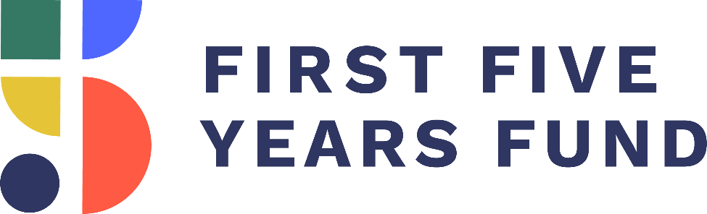

High-Quality Early Learning and Care Toolkit for the
116th Congress

www.ffyf.org

Overview

This document has been prepared by the First Five Years Fund (FFYF) to serve as a resource regarding access to high-quality, affordable early childhood education opportunities. The document provides facts and messaging about policies and programs that, directly or indirectly, help achieve the goal of improving access to affordable early learning and child care from birth through age five.

This resource is intended for policymakers and their staffs, as well as early childhood education stakeholders and advocates, and serves as an up-to-date guide for ways to discuss federal support for, and investments in, early learning and child care. With Congress' bipartisan leadership, we have achieved significant progress over the past year in advancing priorities that benefit our nation's youngest learners. This document will help your team articulate all of the gains you have helped secure, as well as identify opportunities for you to demonstrate how this support benefits your community.

If you have follow-up questions on the material in this document or are interested in additional information on a specific topic or policy, feel free to email Sarah Rubinfield, FFYF Government Affairs Director, at srubinfield@ffyf.org. Please also contact us for assistance in scheduling a site visit or tour in your state or district.

Table of Contents

- Executive Summary

- Why Make High-Quality Early Childhood Education a Priority: Top 10 Facts and Key Early Childhood Education Talking Points

- Congress Demonstrates Broad, Bipartisan Support for Early Childhood Education

  - Policy Actions Demonstrating National Bipartisan Support P. 9

  - Recent Budget and Appropriations Developments P. 13

- Why Early Learning is a Top Priority for Constituents

  - FFYF's Annual Voter Poll Results P. 16

- How Lawmakers Can Demonstrate Their Support

  - Top 10 Early Childhood Education In-District Activities P. 18

  - Opportunities for Congressional Involvement P. 23

  - Draft Constituent Materials P. 25

I. Executive Summary

The following toolkit equips your office with the necessary facts, messaging, and resources to be a champion for investments in high-quality early childhood education. Highlights from the document include:
Top 10 Early Learning Facts

- Every dollar invested in high-quality early childhood education can return up to $7.30.
- Children who participated in high-quality early childhood education had higher college graduation rates and rates of employment at age 30 than peers who did not.
- Approximately half of Americans live in "child care deserts"—neighborhoods or communities with little or no access to quality child care.
- Only 40 percent of three-year-olds are enrolled in early childhood programs in America, below the Organisation for Economic Co-operation and Development (OECD) average of 70 percent.
- The social skills children acquire as babies are directly linked to their long-term social capabilities in adulthood.
- A supportive learning environment prepares children for success. Studies have found quality early childhood education programs increased students' likelihood of high school graduation by 44 percent, increase adult earnings by 42 percent, and reduced incarceration rates by 46 percent.,,
- High-quality child care delivers long-term benefits to children's cognitive and socioemotional development.
- Children who have participated in high-quality early childhood education initiatives go on to have lower rates of incarceration, lower rates of arrest for violent crimes, and are less likely to have received government assistance.
- Child care helps parents return to work and generate an additional $79,000 in lifetime earnings for mothers.
- Early childhood education reduced the percentage of children repeating a grade by 15 percent.

Key FFYF 2018 Polling Results
A majority of voters on both sides of the aisle are watching to see if members are working together to break partisan gridlock and get things done in the new Congress.
Only 15 percent of voters say that most or all local early childhood education programs available to lower- and middle-income families are high-quality and affordable.
Over 74 percent of Democrats and independents want to see increased funding for early childhood education, even if the Trump administration can take credit for helping children and families.

Examples Of Congressional And Local Involvement
- Former Speaker of the House Paul Ryan visited Educare Tulsa (April 2016)
- Senator Murray (D-WA) toured a local college's early learning center and discusses access to child care (October 2017)
- Former Congressman Kevin Yoder (R-KS) and Congresswoman Stephanie Murphy (D-FL) introduced bipartisan legislation for affordable child care (October 2017)

II. Why Make High-Quality Early Childhood Education a Priority: Key Early Childhood Education Talking Points

Sample Talking Points

Investing in early childhood education now is an investment in our community's future. That's why I'm proud of our recent efforts in Congress to provide federal support for early learning and child care programs throughout our state.
- Children from low-income families who receive a high-quality early childhood education are more likely to earn higher wages, live healthier lives, avoid incarceration, raise stronger families, and contribute to society.
  - High-quality early childhood education is also associated with long-term health benefits, including reduced rates of depression, smoking, and substance abuse.
  - Other long-term gains include lower rates of incarceration (46 percent reduction) and lower rates of arrest for violent crimes (33 percent reduction), and lower likelihood of receiving government assistance (26 percent reduction).
- The benefits of high-quality programs from birth through age five do not end with one child but extend to their entire family, now and in the years to come.
  - The positive effects of early childhood interventions are evident even 30 years in the future.
  - Access to stable, high-quality child care also helps parents improve labor productivity by allowing parents to increase hours worked, miss fewer work days, and pursue education.

In 2018, Members of Congress on both sides of the aisle have come together multiple times to take bipartisan action in support of our nation's youngest constituents.
- The FY2019 Labor/HHS Minibus package again prioritized the care of America’s young children by including a $260 million increase for federal early learning and care programs.
  - The bill increased funding for the Child Care and Development Block Grant (CCDBG) program by $50 million to a total of $5.28 billion in discretionary funding, building on the historic $2.37 billion increase the program received in FY2018 through a bipartisan deal.
  - The bill also increased funding levels for Head Start and Early Head Start by $200 million for a total of $10.06 billion and the IDEA Preschool Grants program by $10 million for a total of $391.12 million, while continuing funding for the Preschool Development Grants program at $250 million.
- The FY2018 Omnibus Appropriations bill included a significant funding increase for some of the nation's vital early learning and care programs.
  - The bill increased discretionary funding for the Child Care and Development Block Grant (CCDBG) program to $5.23 billion – the single largest increase to CCDBG in the program's history. This represents an increase of $2.37 billion over FY2017 levels and nearly doubled the program's discretionary funding.
  - The bill also included significant funding levels for Early Head Start and Head Start, as well as the Preschool Development Grants program, setting funding for those programs at $9.86 billion and $250 million, respectively.
Investments today will allow more access to high-quality programs, giving children a strong foundation for the future, regardless of socioeconomic background.
- When children enter kindergarten behind their peers, they are more likely to stay behind. Particularly for children from low-income families, these achievement gaps persist through high-school, impacting the rest of their lives.
  - High-quality early childhood education reduces attendees' timidity and improves attentiveness.
  - High-quality early learning programs aimed at disadvantaged children help close the achievement gap, increasing IQ scores by up to 10 points.
- Investing in high-quality care in a child's first five years ensures they develop the skills necessary for learning, decreasing the need to invest in costly inventions later in life.
  - Preschool reduced the percentage of children repeating a grade by 15 percent. It also lowered the rate of special education placement by 10 percent.
  - Early learning and care increases high school graduation rates by 14 percent.

Early childhood education programs help support working parents across the country. With a record number of women in the workforce today, working moms in particular stand to benefit from these investments in child care and early learning programs.
- Without access to early learning and care, parents tend to miss work, lowering household incomes and potentially leading to job loss.
  - A lack of child care causes businesses to lose an estimated $4.4 billion annually due to employee absenteeism.
  - Working families who can't access affordable child care lose $8.3 billion in wages annually.
- Access to affordable, reliable, and high-quality early learning and care opportunities provides working families with better job stability and overall economic security.
  - Child care helps parents return to work and generate an additional $79,000 in lifetime earnings for mothers.
- Unfortunately, the need to access this critical support far outpaces current capacity, and many families across the country cannot afford the cost of quality child care.
  - Today, center-based care costs families an average of $10,000 dollars per year.
  - A lack of child care causes 45 percent of parents to miss work.

Supporting families with the cost of quality preschool and child care will result in a more efficient and productive workforce for years to come, strengthening our communities and setting a strong foundation for the future.

III. Congress Demonstrates Broad, Bipartisan Support for Early Childhood Education

- Policy Actions Demonstrating National Bipartisan Support
Congress has a strong, bipartisan track record of support for funding early learning programs. Members on both sides of the aisle have worked together in the spirit of bipartisanship to significantly increase funding, while also enacting reforms to existing early childhood programs that elevate quality and leverage state and local leadership.
Because Congress has been a powerful advocate, more children from birth through age five are able to access critical resources to prepare them for school and life. Congress' continued efforts will help ensure our youngest learners have access to a continuum of high-quality early learning from the very start.
This year, Republican and Democratic Governors from every corner of the nation have used their annual State of the State addresses to highlight their commitment to early childhood education. In fact, one in three U.S. governors who delivered State of the State addresses in 2018 specifically highlighted early learning initiatives. Of those, 59 percent were Republican Governors, and 41 percent were Democrats.
The legislation enacted, as described below, are just a few of the most recent examples of Congress' commitment on behalf of children across the country.

FY2019 Labor/HHS Minibus Package
- Enacted: 9/28/18 (House Vote: 361-61; Senate Vote 93-7)
- Description: The FY2019 Labor/HHS Minibus package again prioritized the care of America’s young children by including a $260 million increase for federal early learning and care programs. The bill increased funding for the Child Care and Development Block Grant (CCDBG) program by $50 million to a total of $5.28 billion in discretionary funding, building on the historic $2.37 billion increase the program received in FY2018 through a bipartisan deal.
  - The bill also increased funding levels for Head Start and Early Head Start by $200 million for a total of $10.06 billion and the IDEA Part B Preschool Grants program by $10 million for a total of $391.12 million, while continuing funding for the Preschool Development Grants program at $250 million.
  - The FY2019 Labor/HHS Minibus package also includes:
    - $805 million for Early Head Start-Child Care Partnerships;
    - $50 million for Child Care Means Parents in School;
    - $5 million for Infant and Early Childhood Mental Health;
    - $391.12 million for IDEA Part B Preschool Grants; and
    - $470 million for IDEA Part C Grants for Infants and Families.
- What This Means: The funding levels included in the FY2019 Labor/HHS Minibus package will support greater access to, and the quality of early childhood education programs that are proven to support children’s healthy development and prepare them for a life of achievement. The funding increases for early learning in the FY2019 Labor/HHS Minibus package were only possible as a result of support by both Republican and Democratic members of Congress.
FY2018 Omnibus Bill
- Enacted: 3/23/18 (House Vote: 256-167; Senate Vote 65-32)
- Description: The FY2018 Omnibus bill included a historic funding increase for some of the nation's vital early learning and care programs. The bill increased discretionary funding for the Child Care and Development Block Grant (CCDBG) program to $5.23 billion – the single largest increase to CCDBG in the program's history. This represents an increase of $2.37 billion over FY2017 levels and nearly doubled the program's discretionary funding.
  - The bill also included significant funding levels for Early Head Start and Head Start, as well as the Preschool Development Grants (PDG) program, setting funding for those programs at $9.86 billion and $250 million respectively. This funding for Head Start and Early Head Start represented an increase of $610 million over FY2017, and includes an expansion of Early Head Start and the Early Head Start-Child Care Partnerships.
  - The FY2018 Omnibus bill also includes:
    - $755 million for Early Head Start-Child Care Partnerships;
    - $50 million for Child Care Means Parents in School;
    - $5 million for Infant and Early Childhood Mental Health;
    - $381.12 million for IDEA Part B Preschool Grants; and
    - $470 million for IDEA Part C Grants for Infants and Families.
- What This Means: Overwhelming bipartisan support on Capitol Hill for early childhood education made greater funding levels possible. CCDBG was last authorized in 2014 to strengthen health and safety requirements for child care providers, increase quality, and improve transparency so families are equipped to choose care that best meets their child’s and family’s needs. The funding increases in the 2018 Omnibus bill will go a long way towards ensuring states are more equipped with the resources needed to continue implementing these important but often costly program improvements, which will in turn promote learning and healthy development.

Maternal Infant and Early Childhood Home Visiting (MIECHV)
- Reauthorized: 2/9/18 (House Vote: 240-186; Senate Vote: 71-28) under the Bipartisan Budget Act of 2018
- Description: Voluntary, evidence-based home visits conducted by nurses, social workers, and trained professionals support pregnant women and families with young children by providing access to critical resources in the early years. The extension of MIECHV under the Bipartisan Budget Act of 2018 maintained current funding levels of $400M per year for funds to states and local grantees for five years. Prior to reauthorization, the program had expired in September 2017.
- What This Means: The partnership between families and home visitors improves health and development, prevents child injuries, reduces ER visits, reduces domestic violence, improves family economic self-sufficiency, and improves the coordination and referrals for other community resources. Many families who participate in voluntary home visiting live in rural parts of the country, a long distance from critical services, making the support they receive from home visiting all the more critical to child and family outcomes. Visits by caring, experience professionals can turn good intentions into good parenting, breaking generations-long cycles of poverty.

Child And Dependent Care Tax Credit
- Reauthorized: 12/22/17 (House Vote: 224-201; Senate Vote: 51-48) under the Tax Cuts And Jobs Act
- Description: The Child and Dependent Care Tax Credit (CDCTC) is the only credit in the tax code specifically created to help families with the the cost of work-related child care expenses. After months of uncertainty surrounding the fate of the CDCTC within the tax reform discussion, bipartisan leaders in the Senate prevailed in early December in protecting the credit from being eliminated in the legislation. Last-minute efforts to include an amendment that would have made the credit refundable were unsuccessful, however, leaving the credit unchanged and still out of reach for many low- and middle-income families with lower tax liability.
- What This Means: The CDCTC was created in 1976 to help working parents with work-related child care expenses. Congress approved a temporary increase to the credit in 2001, and in 2012 a bipartisan majority voted to make that expansion permanent. Because the CDCTC is not a refundable credit, most low- and some middle-income, tax-paying families with qualified expenses are unable to take advantage of the credit. Therefore, higher-income families have benefited most from the tax credit. FFYF is working with bipartisan leaders to strengthen the CDCTC so that more families – particularly those who would benefit most – are eligible to receive it.
The Every Student Succeeds Act (ESSA)
- Enacted: 12/10/15 (House Vote: 359-64; Senate Vote: 85-12)
- Description: This education law replaced its outdated predecessor, the No Child Left Behind Act (NCLB). ESSA accomplishes the following:
  - Shifts decision-making responsibility to states with federal guardrails for quality;
  - Incorporates early learning provisions throughout; and
  - Authorizes dedicated funding for early learning through the Preschool Development Grants program.
- What This Means: States have the opportunity to use federal dollars to invest in early learning, enabling them to build upon local innovations to coordinate an early childhood system and allowing states to take the lead on increasing access to preschool. The departure from NCLB's federal emphasis means that states will take on more decision-making responsibilities and will be able to address early learning needs as they exist within a state's specific context.

Child Care and Development Block Grant (CCDBG)
- Reauthorized: 11/19/14 (House Vote: Voice Vote; Senate Vote: 88-1)
- Appropriations: A discretionary funding increase of $2.37 billion was included in the FY2018 Omnibus bill, nearly doubling the program's funding. Additionally, the FY2019 Labor/HHS Minibus package provided a discretionary funding increase of $50 million.
- Description: First enacted in 1990, CCDBG is the primary federal funding source providing financial assistance to low-income working families that access child care. In November 2014, the CCDBG Act was reauthorized with bipartisan support for the first time in 18 years. In order to improve the quality of child care programs, the reauthorized law includes reforms aimed at promoting family involvement, strengthening health and safety standards, improving training for the child care workforce, enhancing continuity of care, and increasing the percentage of children from low-income families in high-quality programs. The increase of $2.37 billion in FY2018 and the $50 million increase in FY2019 for CCDBG will help states implement the quality improvements put forth in the Act, leading to better outcomes for children from low-income families.
- What This Means: States are struggling with the cost of implementing the critically important reforms included in CCDBG reauthorization. Increased funding in the FY2018 Omnibus bill and the FY2019 Labor/HHS Minibus package will enable states to provide children and families access to high-quality child care without being forced to reduce the already shrinking numbers of children who receive child care assistance or reduce payments to child care providers. The reforms Congress passed into law hold great promise, but without continued funding increases, the goals of CCDBG reauthorization could go unfulfilled and working parents will find it even more challenging to obtain the help in paying for child care that they need to find and keep a job to support their children.

III. Why Early Childhood Education has Broad, Bipartisan Support

B) Recent Budget and Appropriations Developments
Federal funding is crucial to promoting investment in early learning at the state and local level. This support ensures early learning programs can properly serve families and accomplish the goals and activities authorized by law. Fortunately, even in the face of limited resources, Congress has consistently increased funding levels for early learning and care programs with overwhelming bipartisan support. The following programs make up the core federal support for early childhood education and child care that receive funding through Congressional appropriations.

Child Care and Development Block Grants (CCDBG)
- Congress agreed to a much-needed increase for the Child Care and Development Block Grant (CCDBG) program in its 2018 bipartisan budget deal. As a result of the two-year budget deal, the FY2018 Omnibus bill increased funding by $2.37 billion for CCDBG, nearly doubling the program’s discretionary funding. The FY2019 Labor/HHS Minibus package built on this historic increase and provided an additional $50 million increase for CCDBG in FY2019 for a total of $5.28 billion.
- CCDBG, in partnership and coordination with other early learning funding at the federal, state, and local levels, allows parents to work while their children attend child care that promotes learning and healthy development. Establishing continuous access to affordable, reliable, and high-quality early learning and care opportunities promotes job stability for working families and overall economic security.
- HHS' FY2019 budget documents state that CCDBG and Head Start "offer a two-generation strategy toward upward economic mobility that allows parents and guardians to pursue self-sufficiency while helping their children receive care and education." By significantly increasing investment in CCDBG, American families and the American economy stand to benefit both from a child development and a workforce standpoint.
Preschool Development Grants (PDGs)
- The FY2018 Omnibus bill and the FY2019 Labor/HHS Minibus package provided funding for the Preschool Development Grant (PDG) program at $250 million, which is the same as the FY2017 level.
- The purpose of PDGs is to improve the coordination and quality of, as well as access to, early childhood education programs for low- and moderate-income children from birth to age five.
- PDGs encourage thoughtful strategic planning and promote sharing of best practices among early childhood education program providers. This collaboration ensures federal, state, and local resources are used effectively to support a continuum of care for young learners.
- The PDG program was authorized with bipartisan support under the Every Student Succeeds Act (ESSA) as a way to improve the delivery of high-quality early learning for our most vulnerable children by bolstering coordination and collaboration.
Head Start
- The FY2019 Labor/HHS Minibus package and the FY2018 Omnibus bill included significant funding increases for Early Head Start and Head Start of $200 million and $610 million, respectively. In FY2019, the total funding level for Early Head Start and Head Start is $10.06 billion, including an expansion of Early Head Start and the Early Head Start-Child Care Partnerships.
- Head Start centers on empowering families and communities with the knowledge and resources they need to ensure that the next generation is able to succeed at every stage of life. It is an especially critical resource for families who would otherwise lack access to high-quality child care and early learning services. According to a 2018 report from the Center for American Progress, Head Start serves nearly every rural county in America, delivering educational, health, and parent education services.
- Research shows that continuous access to full-day, full-year early childhood education improves the likelihood of successful outcomes for young children from low-income backgrounds. Based on this research, HHS revised its Head Start Program Performance Standards in November 2016 to focus on positive child outcomes, including the expectation that, over time, all Head Start programs would serve children for a full school day and full school year.
  - However, HHS recently had to waive a requirement that 50 percent of Head Start center-based programs extend their services to the equivalent of full-day, full-year by August 2019. The notice of the waiver stated that this action was necessary due to insufficient funding.
  - 100 percent of Head Start center-based programs will need to provide the equivalent of full-day, full-year by August 1, 2021.
Early Head Start-Child Care Partnerships
- Congress demonstrated its continued commitment to the importance of the Early Head Start Expansion and Early Head Start – Child Care Partnerships (EHS-CCP) by including a $50 million increase in the FY2019 Labor/HHS Minibus package, which built on a $115 million increase in the FY2018 Omnibus bill.
- EHS-CCP bring together the best of Early Head Start and child care through layered funding to provide comprehensive and continuous services to low-income infants, toddlers, and their families. Under EHS-CCPs, 275 grantee partners with more than 1,400 local child care centers and 1,000 family child care programs are providing quality early childhood education for over 32,000 infants and toddlers.

EARLY LEARNING FUNDING ADVOCACY EFFORTS
PROGRAM |  | FY2018 FUNDING  LEVEL | FY2019 HOUSE APPROPS SUBCOMMITTEE | FY2019 SENATE APPROPS SUBCOMMITTEE | FY2019  FUNDING LEVEL
HEAD START/  EARLY HEAD START | TOTAL PROGRAM  FUNDING | $9.86 billion | $9.91 billion | $10.11 billion | $10.06 billion
 | Funding Increase | +$610 million | +$50 million  (over FY2018) | +250 million  (over FY2018) | +$200 million  (over 2018)
 | Early Head Start –  Child Care Partnerships  (EHS-CCP) | $755 million | $780 million | $755 million | $805 million
 | EHS-CCP Increase | +$115 million | +$25 million  (over FY2018) | Level | +$50 million  (over FY2018)
PRESCHOOL  DEVELOPMENT GRANTS | TOTAL PROGRAM FUNDING | $250 million | $250 million | $250 million | $250 million
 | Funding Increase | Level | Level | Level | Level
CHILD CARE AND DEVELOPMENT  BLOCK GRANT | TOTAL DISCRETIONARY PROGRAM  FUNDING | $5.23 billion | $5.23 billion | $5.23 billion | $5.28 billion
 | Funding Increase | +$2.37 billion | Level with FY2018 – maintains funding increase | Level with FY2018 - maintains funding increase | +$50 million  (over FY2018)

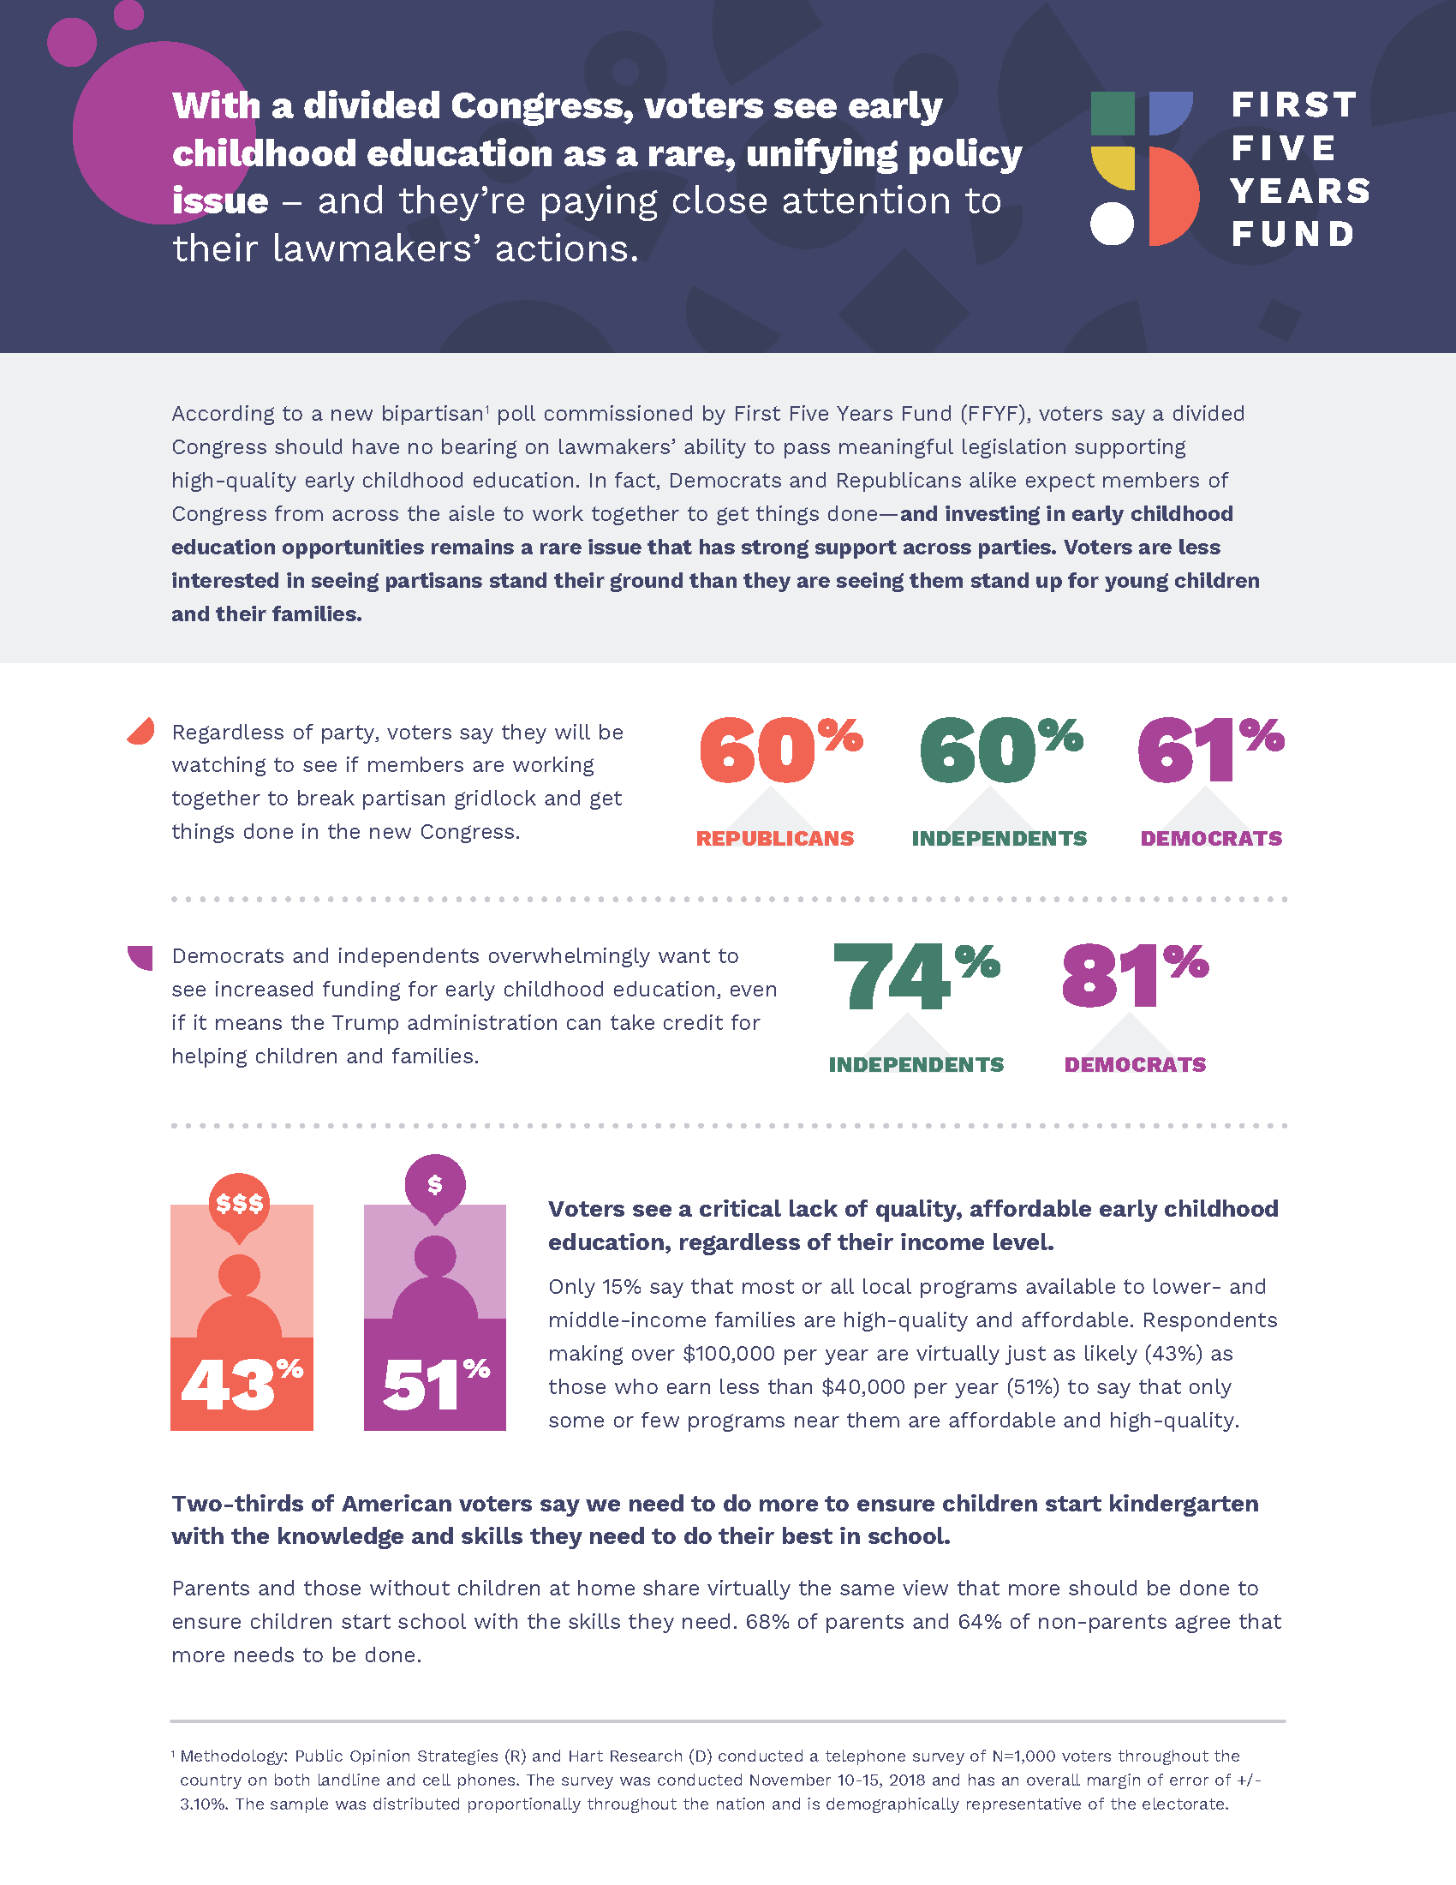
IV. Why Early Learning is a Top Priority for Constituents

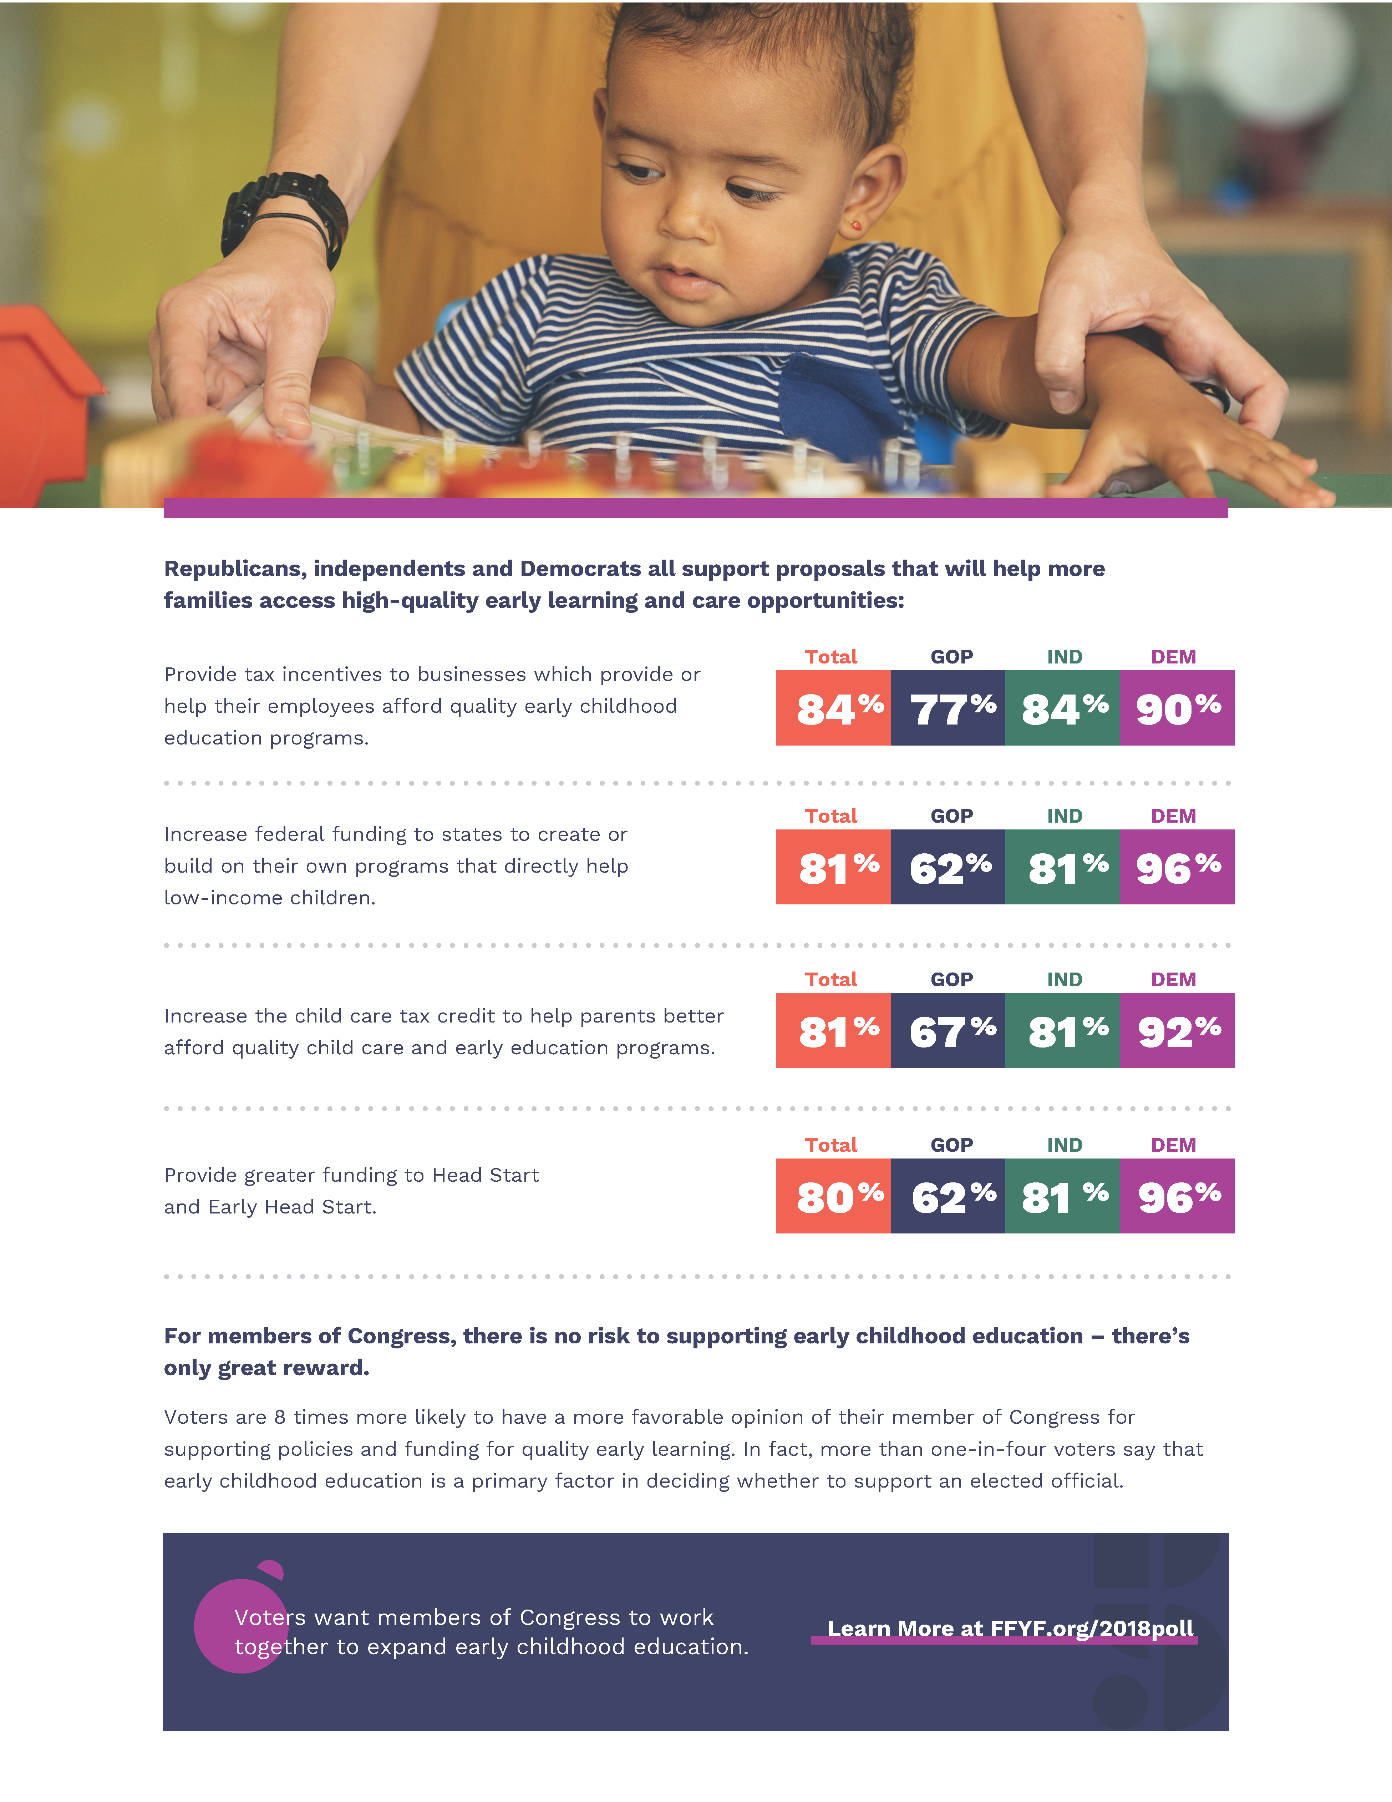

V. How Lawmakers Can Demonstrate Their Support

In-district work periods are times for members to go home and reconnect with the communities they serve. While in your district, here are ten things your office can do to promote early childhood care and education.

Convene Local Stakeholders

- Host a neighborhood roundtable on quality child care in your area.
Early childhood care and education is a priority for voters. According to FFYF's national poll, 89 percent of voters support making quality early childhood education for children more affordable for working families. Seventy-nine percent of voters want Congress and the Administration to work together to improve the quality of child care and preschool, and to make these opportunities more affordable.

How To Take Action:

Step 1: Contact Sarah Rubinfield, FFYF Government Affairs Director, at srubinfield@ffyf.org to be put in touch with local early childhood education advocates in your area.
Step 2: Work with local child care provider to host an event at their facility and identify interested facility administrators, caretakers, and parents to participate.
Step 3: Invite local leaders interested in child care policies to join the roundtable.
Step 4: Prepare discussion questions regarding the obstacles to ensuring every child has access to affordable, high-quality child care.

- Host a community meeting with early learning providers and professionals to discuss their experiences in the classroom.
Teachers are on the front lines when it comes to early learning and child care. Thus, conversations with teachers are critical to finding out about the issues affecting children in your community. These conversations are also a great way to empower teachers to make positive changes and advocate for the policies that they believe in.

How To Take Action:

Step 1: Contact Sarah Rubinfield, FFYF Government Affairs Director, at srubinfield@ffyf.org to be put in touch with local early childhood education advocates in your area.
Step 2: Ask the advocate to connect you with a local early learning provider to gauge their interest in hosting the member for a dialogue with early learning providers and administrators.

Step 3: Once scheduled, prepare discussion questions on the challenges early learning providers face in providing the best-possible care and education to young learners.

Gain First-Hand Knowledge

- Tour a child care facility.
Pick a local child care facility and schedule a visit to learn more and connect with local children and child care professionals.

How To Take Action:

Step 1: Contact Sarah Rubinfield, FFYF Government Affairs Director, at srubinfield@ffyf.org to be put in touch with local early childhood education advocates in your area.
Step 2: Ask the advocate to connect you with a local child care facility to gauge their interest in hosting the member for a tour of the facility.

Step 3: Once scheduled, prepare questions for the member to ask on the tour about quality measures or innovations the facility has implemented to provide the best-possible care and education to young learners.

- Visit with families participating in home-based child care.
Most children in America are cared for by home-based child care providers. Every day, thousands of Americans open their homes and hearts to children from their communities. These small businesses are on the front lines of making sure children start out strong. Visit with these professionals and the families they serve to see the importance of diversity in options for parents, and the needs of these providers.

How To Take Action:

Step 1: Contact Sarah Rubinfield, FFYF Government Affairs Director, at srubinfield@ffyf.org to be put in touch with local early childhood education advocates in your area.
Step 2: Ask the advocate to connect you with a local home-based child care provider to gauge their interest in facilitating the member's visit with families participating in home-based child care.
Step 3: Once scheduled, prepare questions for the member to ask about parents' decision to opt for home-based child care, and what policies could help make child care more accessible/affordable for their family.

- Meet with a child psychologist to discuss the effects of the opioid epidemic on children and families in your community.
The opioid epidemic has presented new challenges to early learning and child care providers and psychologists in communities across the U.S., as these individuals are on the front lines when it comes to childhood trauma. Exposure to adverse childhood experiences or potential dependencies at birth, such as those resulting from a parent's addiction to opioids, can have an emotional and developmental effect on children for the rest of their lives. As noted in a House Dear Colleague Letter in April 2018, Head Start programs are already treating neonatal abstinence syndrome and employing other resources to help families overcome addiction. Home visiting has also been proven to have a positive effect on at-risk families who may be struggling with addiction. By supporting programs like Head Start and home visiting, lawmakers can ensure families receive personal support from pregnancy through their children's first years of life.

How To Take Action:

Step 1: Reach out to a local university or hospital to acquire contact information for local child psychologists working with patients living with a family affected by opioid addiction.
Step 2: Contact a child psychologist to gauge their interest in meeting the member for a discussion on the opioid epidemic.
Step 3: Once scheduled, prepare questions for the member to ask about the challenges facing patients and providers in the midst of the opioid crisis, and how policymakers can better support families grappling with the epidemic.

- Read to a group of children in your community.
Reading and speaking to children is one of the best ways to build their vocabulary and help their brains grow and develop. Taking an afternoon to read to local children is a great way to promote the value of reading and education in your community, and encourage literacy for children and adults.

How To Take Action:

Step 1: Contact Sarah Rubinfield, FFYF Government Affairs Director, at srubinfield@ffyf.org to be put in touch with local early childhood education advocates in your area.
Step 2: Ask the advocate to connect you with a local early childhood education facility to gauge their interest in facilitating the member's visit to read to children.

Step 3: Once scheduled, select a book or two that were favorites of the member's when he/she was young or reading with their children.

- Meet with nurses or other home visiting practitioners funded by the Maternal, Infant, and Early Childhood Home Visiting (MIECHV) Program, and accompany them on a visit.
Parents are a child's first and best teacher. But for parents who are experiencing poverty, drug addiction, language barriers or geographic isolation, voluntary home visiting can be a valuable resource for supporting them to be the best advocate for their child's learning, health, and development in the early years, including serving pregnant mothers. Through regular, planned, and voluntary home visits, parents develop skills aimed at supporting their family's health and economic self-sufficiency. Meeting with a trained home visiting provider and joining a home visit is a great way to learn more about this vital lifeline to families across America.

How To Take Action:

Step 1: Contact Cynthia Phillips, Acting Director of the Health Resources And Services Administration's Maternal and Child Health Bureau, Division of Home Visiting and Early Childhood Systems.
Step 2: Ask Phillips to connect you with a local home visiting administrator.
Step 3: Call the administrator and gauge their interest in facilitating the member's visit with nurses or other home visiting practitioners and families, as well as accompanying them on a visit to a family participating in the program.
Step 4: Once scheduled, prepare questions for the member to ask about how the five-year extension of MIECHV has benefitted parents in the community and the support the program provides to families. Seek to learn how additional policies could help make child care more accessible/affordable for families in the district.

Establish Thought Leadership On Early Childhood Education

- Organize a task force on early childhood education.
Convening community stakeholders is the best way to find out information about the issues that are truly affecting children and families in your area. This type of task force can serve as a driving factor behind local early childhood education initiatives throughout the year.

Step 1: Contact Sarah Rubinfield, FFYF Government Affairs Director, at srubinfield@ffyf.org to be put in touch with local early childhood education advocates in your area.
Step 2: Gauge the advocate's willingness to work with your office to organize an early childhood education task force.
Step 3: Invite local providers, early childhood education educators, professors, entrepreneurs, health care professionals, or parents to join your early childhood education task force.
Step 4: Once the task force is established, schedule a convening when the member will be in-district at a local child care provider, school, or library.
Step 5: Establish goals for the task force to develop solutions and engage the community to raise awareness of the importance of early childhood education.

- Ask business leaders about the importance of access to quality child care for their employees.
Research shows lack of access to affordable child care has a dramatic effect on businesses and economic productivity in the U.S. In addition to causing about half of parents to miss work at least once every six months due to child care breakdowns, lack of access to affordable child care contributes to a nationwide cost of $8.3 billion in lost wages annually. Access to stable, high-quality child care helps parents improve their labor productivity by increasing work hours, missing fewer work days, and pursuing further education. Visiting with local business owners to discuss the need for affordable child care options is a great way to show support for pro-family workplace policies that encourage both economic growth and access to high-quality early childhood education.

How To Take Action:

Step 1: Contact the local Chamber of Commerce, entrepreneurs, or businesses to set up individual meetings or a public event on the challenges their employees face in accessing high-quality child care. Seek out businesses that offer child care opportunities on location when possible.
Step 2: Prepare questions for the member to ask about how companies are supporting their employees in accessing child care, how policies could make high-quality care options more accessible and affordable, and the how investments in child care generate dividends for a local economy.

- Write an op-ed on federal support for early childhood care and education.
As a Member of Congress, your support for early childhood education can mean the world to families struggling to find options for their children. Writing an op-ed on your support for the programs that many of these families rely on is a great way to connect with your constituents, and use your platform to speak up for the youngest constituents in your community.

How To Take Action:

Step 1: Draft an op-ed on the member's support for a specific federal program or general support for investing in early childhood care and education.
Step 2: Consider co-authoring the piece with a local early childhood education provider, caretaker, or business leader.
Step 3: Submit the op-ed to a publication in your state or district, or publish as a blog post on your website.

V. How Lawmakers Can Demonstrate Their Support

- Opportunities for Congressional Involvement

Congress has a strong bipartisan track record of working together on behalf of America's youngest learners and their families. Below please find information on relevant Congressional caucuses that are currently working to achieve strong investments and partnerships with states and communities through bipartisan federal advocacy.

Congressional Pre-K Caucus:
The Congressional Pre-K Caucus is a bipartisan group that seeks to gain a deeper understanding of the benefits of early childhood education and promote policy recommendations to expand high-quality pre-k access in the United States.

- Rep. Joaquin Castro – (D-TX-20) (Co-chair)
- Rep. Katherine Clark – (D-MA-05) (Co-chair)
- Rep. Thomas Cole – R-OK-04 (Co-chair)
- Rep. Stephen Cohen – (D-TN-09)

- Rep. Deborah Dingell – (D-MI-12)
- Rep. James Langevin – (D-RI-02)
- Rep. Tom O'Halleran – (D-AZ-01)
- Rep. Scott Peters – (D-CA-52)
- Rep. Robert (Bobby) Scott – (D-VA-03)

For information on joining the Congressional Pre-K Caucus, please reach out to the offices of the co-chairs:

Rep. Joaquin Castro
202-225-3236
1221 Longworth House Office Building
http://castro.house.gov/

Rep. Katherine Clark
202-225-2836
1415 Longworth House Office Building
http://katherineclark.house.gov/

Rep. Thomas Cole
202-225-6165
2467 Rayburn House Office Building
http://cole.house.gov/

Congressional Baby Caucus
The Congressional Baby Caucus aims to ensure public policy reflects the latest research in understanding how children's brains are shaped and developed, how positive behaviors can be encouraged, and how investments in early childhood create success in later years. The group is also committed to ensuring families are supported with the resources they need to take advantage of scientific advances.
The Caucus focuses on a broad range of areas, including: nutrition and basic needs for babies; the effects of trauma; and federal programs like Head Start and Child Care and Development Block Grants.

- Rep. Rosa DeLauro – (D-CT-03) (Co-chair)
- Rep. Charles Fleischmann – (R-TN-03) (Co-chair)
- Rep. Brendan Boyle – (D-PA-13)
- Rep. Julia Brownley – (D-CA-26)
- Rep. Katherine Clark – (D-MA-05)
- Rep. Jim Cooper – (D-TN-05)
- Rep. Deborah Dingell – (D-MI-12)
- Rep. Raul Grijalva – (D-AZ-03)
- Rep. Jim Himes – (D-CT-04)
- Rep. Dave Joyce – (R-OH-14)
- Rep. Betty McCollum – (D-MN-04)
- Rep. Mark Takano – (D-CA-41)
- Rep. John Yarmuth – (D-KY-03)

For information on joining the Congressional Baby Caucus, please reach out to the offices of the co-chairs:

Rep. Rosa DeLauro
202-225-3661
2413 Rayburn House Office Building
http://delauro.house.gov/
Rep. Charles Fleischmann
202-225-3271
2410 Rayburn House Office Building
http://fleischmann.house.gov

Moms In The House Caucus
Representative Debbie Wasserman Schultz (D-FL-23) has announced plans to create an informal "Moms in the House" Caucus. Rep. Schultz is launching the caucus to make Congressional protocols more parent-friendly.
For information on the effort, please reach out to Rep. Schultz's office:
Rep. Debbie Wasserman Schultz
202-225-7931
1114 Longworth House Office Building
http://wassermanschultz.house.gov

V. How Lawmakers Can Demonstrate Their Support

- Draft Constituent Materials

Sample Tweets

Policies that invest in high-quality early childhood education pay off; every dollar we spend returns up to $7.30. That's why I'll continue advocating for policies that invest in our country's youngest learners. #ECE

We've made great strides to make quality, affordable child care available to Americans across the country—but it remains out of reach for far too many families. I look forward to address this challenge with colleagues on both sides of the aisle. #ECE

Sample Facebook Posts

Child care is critical to ensure infants can learn and play in a safe, supportive environment. It also enables parents to return to work or school; research has found that child care ultimately generates an additional $79,000 in lifetime earnings for mothers. I am committed to advocating for policies that make child care more affordable and accessible, especially for low-income families.

Time and again, research has proven that high-quality early childhood education programs increase students' likelihood of high school graduation, increased adults' earning potential, and reduced incarceration rates. And yet, just 40 percent of three-year-olds in the U.S. are enrolled in early childhood programs—a rate far below those of many peers around the world. I look forward to working with my colleagues on both sides of the aisle to increase families' access to affordable, quality early childhood education.

Sample 499

Making sure families can access affordable, high-quality early learning and child care opportunities is criticial to helping families break the cycle of poverty and build a brighter future. And overwhelming research shows investing in early learning initiatives targeted to the first five years of children's lives generate many long-term benefits, including higher likelihood of high school graduation, greater lifetime earnings, and reduced incarceration rates.

My conversations with teachers and families across our [district/state] have proven there is strong support for investing in early learning and care. Last year, I was proud to help pass legislation to increase funding for Early Head Start and Head Start by $610 million, providing critical support to prepare children from low-income families for school. I also voted to reauthorize the Maternal, Infant, and Early Childhood Home Visiting (MIECHV) program, which allocates federal funds to states for voluntary, evidence-based home visiting services. In 2017 alone, MIECHV provided more than 942,000 home visits, helping parents to improve their family's health and provide better opportunities for their children.

This year, I will continue to seek out opportunities to invest in early childhood education. To follow my continued efforts on this issue and others, you can sign up for my e-newsletter by emailing [insert email address] or contact my office through my website at [insert URL].

Sample E-Newsletter

Hi friends,

Earlier this week, I joined with my colleagues to pass a major bipartisan achievement—a historic investment in America's families and youngest learners through funding increases for the Child Care and Development Block Grant (CCDBG) program. This bipartisan achievement demonstrates that Republicans and Democrats agree on the importance of prioritizing the care and education of America's young children.

CCDBG is instrumental in expanding access to high-quality child care for lower-income Americans. The program provides block grants to states, which then distribute the money to offset the cost of child care for low-income families. Over one million children across the country receive subsidies through this program.

Research has proven that early learning and child care programs play a vital role in children's early learning and development from birth through age five. These programs also help parents provide for their families after the birth of a child. High-quality, reliable, and affordable child care enables parents to improve their labor productivity by increasing work hours, missing fewer work days, or pursuing further education. Plus, child care provides parents with the peace of mind that their children are in safe, supportive environments while they are apart.

Thanks to this CCDBG funding increase, states will continue to expand access to high-quality child care. But our work is not done. Millions of American children eligible for the subsidy still do not receive it. In the months ahead, I will continue to seek ways to expand access to quality child care for all American families.

James Heckman, et al., "Quantifying the Life-cycle Benefits of an Influential Early Childhood Program," National Bureau of Economic Research, 2017
"Research Summary: The Lifecycle Benefits of an Influential Early Childhood Program," Heckman Equation, Accessed 12/6/18
Rasheed Malik and Katie Hamm, "Mapping America's Child Care Deserts," Center for American Progress, 2017
"Starting Strong 2017: Key OECD Indicators on Early Childhood Education and Care," Organisation for Economic Cooperation and Development, 2017
"What Do We Know About Social and Emotional Development in Early Childhood?" The Urban Child Institute, Accessed 12/6/18
Lawrence Schweinhart, et al., "Michigan Great Start Readiness Program Evaluation 2012: High School Graduation and Grade Retention Findings," Michigan Department of Education, March 2012
"Perry Preschool Project," Social Programs That Work, Accessed 12/6/18
"Social Programs That Work Review: Evidence Summary for the Perry Preschool Project," Laura and John Arnold Foundation, November 2017
"The Relation of Preschool Child-Care Quality to Children's Cognitive and Social Developmental Trajectories through Second Grade," Child Development, 2001
"Perry Preschool Project," Social Programs That Work, Accessed 12/6/18
"2016 Report: Parents And The High Cost Of Child Care," Child Care Aware Of America, 2016
Lynn Karoly, Anamarie Auger, "Informing Investments In Preschool Quality And Access In Cincinnati," Rand Corporation, 2016
Ibid.
Coalition For Evidence-Based Policy, Website, Accessed 1/4/17
Arthur Reynolds Et Al., "Effects Of A School-Based, Early Childhood Intervention On Adult Health And Well-Being," Archives of Pediatrics and Adolescent Medicine, 2007
Timothy Bartik, "Early Childhood Programs As An Economic Development Tool: Investing Early To Prepare The Future Workforce," W.E. Upjohn Institute For Employment Research, 2013
"Why All Children Benefit From Pre-K," The Pew Charitable Trust, 2005
Greg Duncan, Katherine Magnuson, "Informing Investments In Preschool Quality And Access In Cincinnati," Rand Corporation, 2016
Ibid.
Lynn Karoly, Anamarie Auger, "Informing Investments In Preschool Quality And Access In Cincinnati," Rand Corporation, 2016
Ibid.
Ibid.
Sarah Jane Glynn, Danielle Corley, "The Cost Of Work-Family Policy Inaction," Center For American Progress, 2016
"2016 Report: Parents And The High Cost Of Child Care," Child Care Aware Of America, 2016
Ibid.
Ibid.
"FY2019 Budget In Brief," U.S. Department Of Health And Human Services," 2/19/18
"Joint Letter On Implementation Of Preschool Development Grants Program," First Five Years Fund, 4/26/18
"House Dear Colleague Letter Supporting Head Start for FY2019, Led by Stivers and Jenkins," First Five Years Fund, 4/9/18
Rasheed Malik and Leila Schochet, "A Compass for Families: Head Start in Rural America," Center For American Progress, 4/10/18
"Early Head Start-Child Care Partnerships," National Center On Early Head Start-Child Care Partnerships. Accessed 4/30/18
FFYF 2017 National Poll.
"Oprah Winfrey's 'Life-Changing' Report on Childhood Trauma," First Five Years Fund
" House Dear Colleague Letter Supporting Head Start for FY2019, Led by Stivers and Jenkins," First Five Years Fund, 4/9/18
" Access to Home Visiting Can Save Families Affected by Opioid Crisis," First Five Years Fund, 2/6/18
"Home Visiting," HRSA, U.S. Department of Health And Human Services
Child Care Aware Of America "2016 Report: Parents And The High Cost Of Child Care," Accessed 12/6/16
Timothy Bartik, "Early Childhood Programs As An Economic Development Tool: Investing Early To Prepare The Future Workforce," W.E. Upjohn Institute For Employment Research, 2013

